Metadata Embedding Procedures  
Using exiftool

These procedures are intended to “parallel” those outlined in “Metadata Batch Editing Using PhotoShop”. These procedures outline how to embed metadata in photos using the command line tool, exiftool.exe.

Exiftool is run from the Microsoft command-line interpreter, cmd.exe.

So start, enter “cmd’ in the

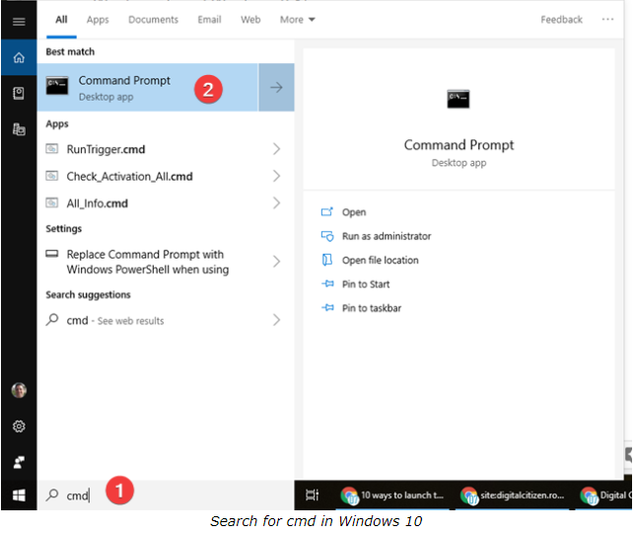

With the CMD Window open, go the directory where the TIFF images reside that need metadata tags added.

Example:

G: <Enter>   
cd My Drive\username\Collections\2008 Lincoln Exhibit\Photos\TIFF <Enter>  
or  
S: <Enter>   
cd S:\SCAN\AV Photo Scans\username\Collections\2008 Lincoln Exhibit\Photos\TIFF <Enter>

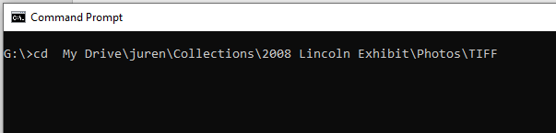

To list all TIFF images in the directory enter:

dir *.tif <Enter>

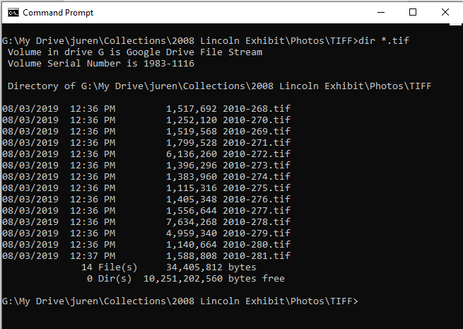

IPTC Tags

AV Archives at the Harry S. Truman Library has adopted the IPTC Metadata Standard for images and photos. (IPTC stands for the International Press Telecommunications Council, a world-wide group of news organizations.)

To embed a single IPTC tag into a TIFF image, the command structure is as follows:

C:\exiftoolgui\exiftool -[tag_name]=“[tag]” [filename]

for example:

C:\exiftoolgui\exiftool -Headline=“2018 Big Sonia Screening” 2010-392.tif

embeds “2018 Big Sonia Screening” into the file 2010-392.tif.

To “bulk” embed a number of IPTC tags into all TIFF images in a directory, copy and paste the following:

C:\exiftoolgui\exiftool^

-Headline=” [Title]”^

 -Caption-Abstract=”[Description]”^

 -ObjectName=”[ Accession Number ]”^

 -By-line=”[ Photographers Name ]”^

 -By-lineTitle=”[ Photographers Title ]”^

 -DateCreated=”[ Date Photograph was created ]”^

-Writer-Editor=”[ Person who entered metadata ]”^

 -Sub-location=”[ Site photo was taken ]”^

 -City=”[ City ]”^

 -Province-State=”[ State ]”^

 -Country-PrimaryLocationName=”[ Country ]”^

-Source=”[ NARA Collection Number e.g. RG-64 ]”^

 -CopyrightNotice=”[ Rights Statement ]”^

-SpecialInstructions=”[ Photographer, Agency, Harry S. Truman Presidental Library and Museum ]”^

 *.tif ^

 | more

For example to bulk embed metadata common to all photos in a directory, enter the following:

C:\exiftoolgui\exiftool^

-Headline=” ”^

 -Caption-Abstract=” ”^

 -ObjectName=” ”^

 -By-line=”Scott Kraft”^

 -By-lineTitle=” Independent ”^

 -DateCreated=”2018:01:18 ”^

-Writer-Editor=”J. U’Ren ”^

 -Sub-location=”Harry S. Truman Library and Museum”^

 -City=”Independence”^

 -Province-State=”MO”^

 -Country-PrimaryLocationName=”USA”^

-Source=”[ NARA Collection Number e.g. RG-64 ]”^

 -CopyrightNotice=”Public Domain – This item is in the public domain and can be used freely without permission.”^

-SpecialInstructions=”Scott Kraft, Independent, Harry S. Truman Presidential Library and Museum ]”^

 *.tif ^

 | more

Note: Headline [Title], Caption-Abstract [Description], and ObjectName [Accession Number] are unique to each photo in a series and will have to be individually entered for each photo.

Each tag needs to be bound in quotes

Items such as Headline, Caption-Abstract and ObjectName that require unique tags and are to be left blank in the “bulk embedding step” can contain empty quotes.

To list all IPTC tags embedded in TIFF images in the directory, copy and paste the following:

C:\exiftoolgui\exiftool^

-Headline^

 -Caption-Abstract^

 -ObjectName^

 -By-line^

 -By-lineTitle^

 -DateCreated^

 -Credit^

-Writer-Editor^

 -Sub-location^

 -City^

 -Province-State^

 -Country-PrimaryLocationName^

-Source^

 -CopyrightNotice^

-SpecialInstructions^

 *.tif ^

 | more

It will look like this:

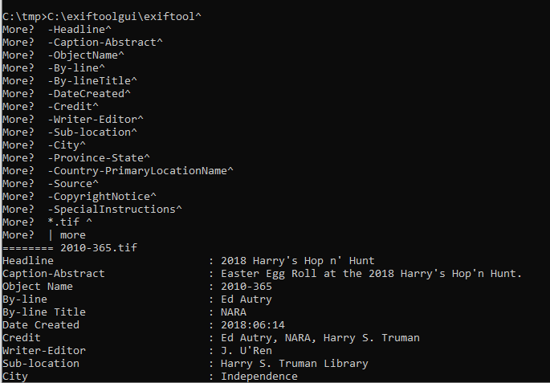

Standard limits for the number of characters in IPTC tags are:

Headline                        : 256

Caption-Abstract                : 2000

Object Name                     : 64  
By-line                         : 32  
By-line Title                   : 32

Date Created                    : 8  
Credit                          : 32

Writer-Editor                   : 32

Sub-location                    : 32  
City                            : 32  
Province-State                  : 32  
Country-Primary Location Name   : 64  
Time Created                    : 11  
Source                          : 32

Copyright Notice                : 128

SpecialInstructions : 128

The full IPTC spec can be found at:

<https://sno.phy.queensu.ca/~phil/exiftool/TagNames/IPTC.html>